**1. Algorithms**

### An algorithm is a type of effective method in which a definite list of well-defined instructions for completing a task; that given an initial state, will proceed through a well-defined series of successive states, eventually terminating in an end-state. The concept of an algorithm originated as a means of recording procedures for solving mathematical problems such as finding the common divisor of two numbers or multiplying two numbers.

### Algorithms are named for the 9th century Persian mathematician Al-Khowarizmi. He wrote a treatise in Arabic in 825 AD, *On Calculation with Hindu Numerals.* It was translated into Latin in the 12th century as *Algoritmi de numero Indorum*, which title was likely intended to mean "[Book by] Algoritmus on the numbers of the Indians", where "Algoritmi" was the translator's rendition of the author's name in the genitive case; but people misunderstanding the title treated *Algoritmi* as a Latin plural and this led to the word "algorithm" (Latin *algorismus*) coming to mean "calculation method".

**Algorithm Specification**

### The criteria for any set of instruction for an algorithm is as follows:

* Input : Zero of more quantities that are externally applied

### Output : At least one quantity is produced

### Definiteness : Each instruction should be clear and unambiguous

### Finiteness : Algorithm terminates after finite number of steps for all test cases.

### Effectiveness : Each instruction is basic enough for a person to carried out using a pen and paper. That means ensure not only definite but also check whether feasible or not.

**Space Complexity**

Space complexity of an algorithm is the amount to memory needed by the program for its completion. Space needed by a program has the following components:

1. **Instruction Space**

Space needed to store the compiled version of program. It depends on

* 1. Compiler used
  2. Options specified at the time of compilation

e.g., whether optimization specified, Is there any overlay option etc.

* 1. Target computer

e.g., For performing floating point arithmetic, if hardware present or not.

1. **Data Space**

Space needed to store constant and variable values. It has two components:

* 1. Space for constants:

e.g., value ‘3’ in program 1.1

Space for simple variables:

e.g., variables a,b,c in program 1.1

**Program 1.1**

int add (int a, int b, int c)

{

return (a+b+c)/3;

}

* 1. Space for component variables like arrays, structures, dynamically allocated memory.

e.g., variables a in program 1.2

**Program 1.2**

int Radd (int a[], int n)

1 {

2 If (n>0)

3 return Radd (a, n-1) + a[n-1];

4 else

5 return 0;

6 }

1. **Environment stack space**

Environment stack is used to store information to resume execution of partially completed functions. When a function is invoked, following data are stored in Environment stack.

* 1. Return address.
  2. Value of local and formal variables.
  3. Binding of all reference and constant reference parameters.

Space needed by the program can be divided into two parts.

i. Fixed part independent of instance characteristics. E.g., code space, simple variables, fixed size component variables etc.

1. Variable part. Space for component variables with space depends on particular instance. Value of local and formal variables.

Hence we can write the space complexity as

S(P) = c + Sp (instance characteristics)

**Example 1.1**

Refer Program 1.1

One word for variables a,b,c. No instance characteristics. Hence Sp(TC) = 0

**Example 1.2**

**Program 1.3**

int Aadd (int *a, int n)

1 {

2 int s=0;

3 for (i=0; i<n; i++)

4 s+ = a[i];

5 return s;

6 }

One word for variables n and i. Space for a[] is address of a[0]. Hence it requires one word. No instance characteristics. Hence Sp(TC) = 0

**Example 1.3**

Refer Program 1.2

Instance characteristics depend on values of n. Recursive stack space includes space for formal parameters, local variables and return address. So one word each for a[],n, return address and return variables. Hence for each pass it needs 4 words. Total recursive stack space needed is 4(n).

Hence Sp(TC) = 4(n).

**Time Complexity**

Time complexity of an algorithm is the amount of time needed by the program for its completion. Time taken is the sum of the compile time and the execution time. Compile time does not depend on instantaneous characteristics. Hence we can ignore it.

Program step: A program step is syntactically or semantically meaningful segment of a program whose execution time is independent of instantaneous characteristics. We can calculate complexity in terms of

1. Comments:

No executables, hence step count = 0

1. Declarative Statements:

Define or characterize variables and constants like (*int* , *long*, *enum*, …)

Statement enabling data types (*class, struct, union, template*)

Determine access statements ( *public, private, protected, friend* )

Character functions ( *void, virtual* )

All the above are non executables, hence step count = 0

1. Expressions and Assignment Statements:

Simple expressions : Step count = 1. But if expressions contain function call, step count is the cost of the invoking functions. This will be large if parameters are passed as call by value, because value of the actual parameters must assigned to formal parameters.

Assignment statements : General form is <variable> = <expr>. Step count = expr, unless size of <variable> is a function of instance characteristics. eg., a = b, where a and b are structures. In that case, Step count = size of <variable> + size of < expr >

1. Iterative Statements:

**While** <expr> **do**

**Do .. While <**expr**>**

Step count = Number of step count assignable to <expr>

**For** (<init-stmt>; <expr1>; <expr2>)

Step count = 1, unless the <init-stmt>, <expr1>,<expr2> are function of instance characteristics. If so, first execution of control part has step count as sum of count of <init-stmt> and <expr1>. For remaining executions, control part has step count as sum of count of <expr1> and <expr2>.

1. Switch Statements:

**Switch** (<expr>) {

**Case** cond1 : <statement1>

**Case** cond2 : <statement2>

.

.

**Default** : <statement>

}

**Switch** (<expr>) has step count = cost of <expr>

Cost of **Cond** statements is its cost plus cost of all preceding statements.

1. If-else Statements:

**If** (<expr>) <statement1>;

**Else** <statement2>;

Step count of **If** and **Else** is the cost of <expr>.

1. Function invocation:

All function invocation has Step count = 1, unless it has parameters passed as called by value which depend s on instance characteristics. If so, Step count is the sum of the size of these values.

If function being invoked is recursive, consider the local variables also.

1. Memory management Statements:

**new** object, **delete** object, **sizeof**(object), Step count =1.

1. Function Statements:

Step count = 0, cost is already assigned to invoking statements.

1. Jump Statements:

**continue, break, goto** has Step count =1

**return** <expr>: Step count =1, if no *expr* which is a function of instance characteristics. If there is, consider its cost also.

**Example 1.4**

Refer Program 1.2

Introducing a counter for each executable line we can rewrite the program as

int Radd (int a[], int n)

{

count++ // if

If (n>0)

{

count++ // return

return Radd (a, n-1) + a[n-1];

}

else

{

count++ // return

return 0;

}

}

Case 1: n=0

tRadd = 2

Case 2: n>0

2 + tRadd (n-1)

= 2 + 2 + tRadd (n-2)

= 2 * 2 + tRadd (n-2)

.

.

= 2n + tRadd (0)

= 2n + 2

**Example 1.5**

**Program 1.4**

int Madd (int a[][], int b[][], int c[][], int n)

1 {

2 For (int i=0; i<m; i++)

3 For (int j=0; j<n; j++)

4 c[i][j] = a[i][j] + b[i][j];

5 }

Introducing a counter for each executable line we can rewrite the program as

int Madd (int a[][], int b[][], int c[][], int n)

{

For (int i=0; i<m; i++)

{

count++ //for i

For (int j=0; j<n; j++)

{

count++ //for j

c[i][j] = a[i][j] + b[i][j];

count++ //for assignment

}

count++ //for last j

}

count++ //for last i

}

Step count is 2mn + 2m +1.

Step count does not reflect the complexity of statement. It is reflected in step per execution (s/e).

Refer Program 1.2

|  |  |  |  |  |  |
| --- | --- | --- | --- | --- | --- |
| **Line** | **s/e** | **Frequency** | | **Total Steps** | |
| **n=0** | **n>0** | **n=0** | **n>0** |
| 1 | 0 | 1 | 1 | 0 | 0 |
| 2 | 1 | 1 | 1 | 1 | 1 |
| 3 | 1 + tRadd (n-1) | 0 | 1 | 0 | 1 + tRadd (n-1) |
| 4 | 0 | 1 | 0 | 0 | 0 |
| 5 | 1 | 1 | 0 | 1 | 0 |
| **Total no. of steps** | | | | **2** | **2 + tRadd (n-1)** |

Refer Program 1.3

|  |  |  |  |
| --- | --- | --- | --- |
| **Line** | **s/e** | **Frequency** | **Total Steps** |
| 1 | 0 | 1 | 0 |
| 2 | 1 | 1 | 1 |
| 3 | 1 | n+1 | n+1 |
| 4 | 1 | n | N |
| 5 | 1 | 1 | 1 |
| 6 | 0 | 1 | 0 |
| **Total no. of steps** | | | **2n + 3** |

Refer Program 1.4

|  |  |  |  |
| --- | --- | --- | --- |
| **Line** | **s/e** | **Frequency** | **Total Steps** |
| 1 | 0 | 1 | 0 |
| 2 | 1 | m+1 | m+1 |
| 3 | 1 | m(n+1) | m(n+1) |
| 4 | 1 | mn | Mn |
| 5 | 0 | 1 | 0 |
| **Total no. of steps** | | | **2mn + 2m + 1** |

**Asymptotic Notations**

Step count is to compare time complexity of two programs that compute same function and also to predict the growth in run time as instance characteristics changes. Determining exact step count is difficult and not necessary also. Since the values are not exact quantities we need only comparative statements like c1n2 ≤ tp(n) ≤ c2n2.

For example, consider two programs with complexities c1n2 + c2n and c3n respectively. For small values of n, complexity depend upon values of c1, c2 and c3. But there will also be an n beyond which complexity of c3n is better than that of c1n2 + c2n.This value of n is called break-even point. If this point is zero, c3n is always faster (or at least as fast). Common asymptotic functions are given below.

|  |  |
| --- | --- |
| **Function** | **Name** |
| 1 | Constant |
| log n | Logarithmic |
| N | Linear |
| n log n | n log n |
| n2 | Quadratic |
| n3 | Cubic |
| 2n | Exponential |
| n! | Factorial |

**1.5.1 Big ‘Oh’ Notation (O)**

O(g(n)) = { f(n) : there exist positive constants c and n0 such that 0 ≤ f(n) ≤ cg(n) for all n ≥ n0 }

It is the upper bound of any function. Hence it denotes the worse case complexity of any algorithm. We can represent it graphically as

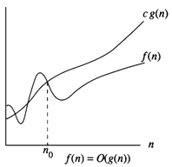

**Fig 1.1**

**Omega Notation (Ω)**

Ω (g(n)) = { f(n) : there exist positive constants c and n0 such that 0 ≤ cg(n) ≤ f(n) for all n ≥ n0 }

It is the lower bound of any function. Hence it denotes the best case complexity of any algorithm. We can represent it graphically as

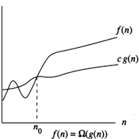

**Fig 1.2**

**Theta Notation (Θ)**

Θ(g(n)) = {f(n) : there exist positive constants c1,c2 and n0 such that c1g(n) ≤f(n) ≤c2g(n) for all n ≥ n0 }

If f(n) = Θ(g(n)), all values of n right to n0 f(n) lies on or above c1g(n) and on or below c2g(n). Hence it is asymptotic tight bound for f(n).

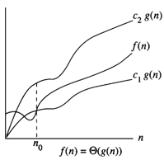

**Fig 1.3**

**Little ‘Oh’ Notation (o)**

o(g(n)) = { f(n) : for any positive constants c > 0, there exists n0>0, such that 0 ≤ f(n) < cg(n) for all n ≥ n0 }

It defines the asymptotic *tight* upper bound. Main difference with Big Oh is that Big Oh defines for some constants c by Little Oh defines for all constants.

**Little Omega (ω)**

ω(g(n)) = { f(n) : for any positive constants c>0 and n0>0 such that 0 ≤ cg(n) < f(n) for all n ≥ n0 }

It defines the asymptotic *tight* lower bound. Main difference with Ω is that, ω defines for some constants c by ω defines for all constants.

* 1. 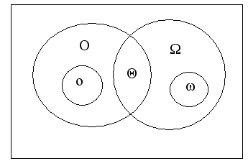  
     **Recurrence Relations**

Recurrence is an equation or inequality that describes a function in terms of its value on smaller inputs, and one or more base cases

e.g., recurrence for Merge-Sort



* Useful for analyzing recurrent algorithms
* Make it easier to compare the complexity of two algorithms
* Methods for solving recurrences
  + Substitution method
  + Recursion tree method
  + Master method
  + Iteration method

**Substitution Method**

* + - Use mathematical induction to derive an answer
    - Derive a function of n (or other variables used to express the size of the problem) that is not a recurrence so we can establish an upper and/or lower bound on the recurrence
    - May get an exact solution or may just get upper or lower bounds on the solution

**2. Divide and Conquer**

### Divide and conquer (D&C) is an important algorithm design paradigm. It works by recursively breaking down a problem into two or more sub-problems of the same (or related) type, until these become simple enough to be solved directly. The solutions to the sub-problems are then combined to give a solution to the original problem. A divide and conquer algorithm is closely tied to a type of recurrence relation between functions of the data in question; data is "divided" into smaller portions and the result calculated thence.

**Steps**

### Splits the input with size n into k distinct sub problems 1 < k ≤ n

* Solve sub problems
* Combine sub problem solutions to get solution of the whole problem. Often sub problems will be of same type as main problem. Hence solutions can be expressed as recursive algorithms

**Control Abstraction**

Control abstraction is a procedure whose flow of control is clear but primary operations are specified by other functions whose precise meaning is undefined

DAndC (P)

{

if Small(P) return S(P);

else

{

divide P into smaller instances P1, P2,…,Pk k>1;

apply DandC to each of these sub problems;

return Combine(DandC(P1), DandC(P2),…,DandC(Pk));

}

}

The recurrence relation for the algorithm is given by



g(n) – time to computer answer directly from small inputs.

f(n) – time for dividing P and combining solution to sub problems

* 1. Merge Sort

Given a sequence of n elements a[1],...,a[n].

Spilt into two sets 

Each set is individually sorted, resultant is merged to form sorted list of n elements

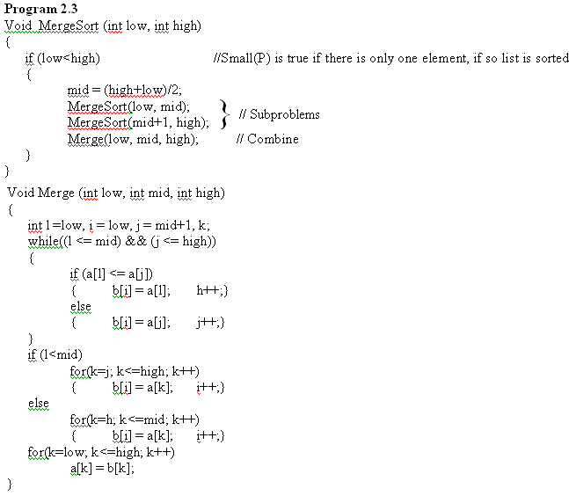

**Example 2.2**

Consider 10 elements 310, 285, 179, 652, 351, 423, 861, 254, 450 and 520. The recursive call can be represented using a tree as given below

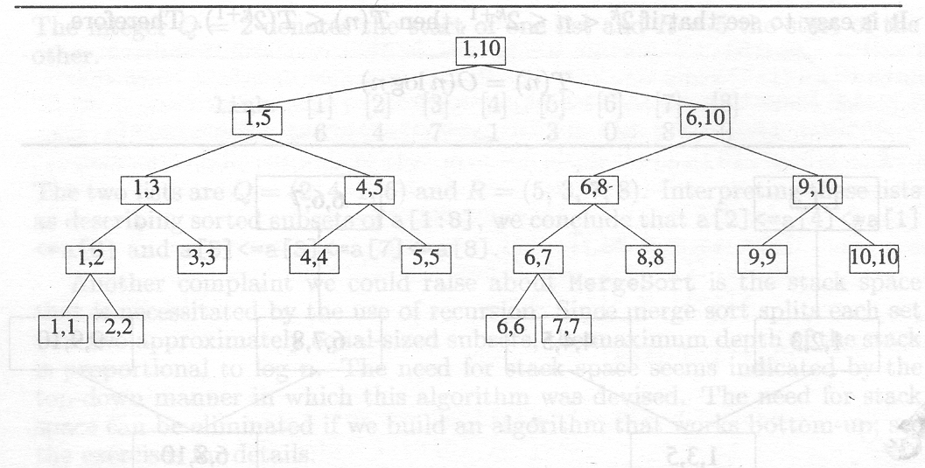

**T(n) = O(nlogn)**

* 1. Quick Sort

Given a sequence of n elements a[1],...,a[n].

Divide the list into two sub arrays and sorted so that the sorted sub arrays need not be merged later. This is done by rearranging elements in the array such that a[i]<=a[j] for 1≤i≤m and m+1≤j≤n, 1≤m≤n. Then the elements a[1] to a[m] and a[m+1] to a[n] are independently sorted, Hence no merging is required.

Pick an element, t=a[s], reorder other elements so that all elements appearing before t is less than or equal to t, all elements after t is greater than or equal to t.

**Program 2.4**

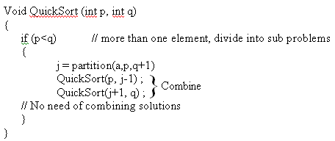

int partition (int a[], int m, int p)

{

int v=a[m], i=m, j=p ;

do

{

do

i++;

while(a[i]<v);

do

j--;

while(a[j]>v);

if (i<j) interchange(a,i,j);

}

while(i<j);

a[m] = a[j]; a[j] = v; return(j);

}

While calculating complexity we are considering element comparison alone. Assume that n elements are distinct and the distribution is such that there is equal probability for any element to get selected for partitioning.